GREEN MARBLE SēLr
Aging Techniques

Green Marble SēLr offers a subtle approach to aging. To achieve the desired affect, the finished product will require a translucent and equally subtle paint. The Skin Illustrator color systems provide the perfect compliment.

To mix the Green Marble SēLr into an ager, you must have Green Marble SēLr concentrate and attagel (powder). Ratios vary between 1 parts attagel, to 3-6 parts SēLr concentrate. The ager does not work with the SPRAY Green Marble SēLr.

Attagel Green Marble Concentrate
1 oz. TO 3 oz. Light ager on most skin types
1 oz. TO 4 oz. Medium Light
1 oz. TO 5 oz. Medium Heavy
1 oz. TO 6 oz. Heavy ager on most skin types

A 1 oz. attagel to 6 oz. GM Concentrate ratio still works well as a fine-line wrinkler when used lightly. The application technique is the same idea as stretch and stipple.*(see note on back panel).

Variables include:
- Desired effect
- Specific area of face
- Elasticity of subject’s skin
- Application method: foam sponge latex vs. brush

With these variables in mind, alter your formula ratios for different areas of your subject’s face in order to customize desired features. This technique may be utilized for the back of your subject’s hands as well.

Your make-up kit should include the following items:

Kleenex Cape Moisturizer(s)
Puffs Skin Illustrator Color palettes Aloe gel
Sponge Makeup Remover(s) Hand Sanitizer
Towels Hair gray/white Spatulas
Hair dryer Scissors Rubber gloves
AF thinner Panasonic groomer Powders
Mascara wands Eye wash/drops Hand fan
Assorted Makeup Brushes Wax palette 99% alcohol
Cups, Q-tips Witch hazel Chubs
Cotton pads Green marble Selr Spray Acetone
Kiehls blue astringent Telesis 4 Thinner
Green Marble SēLr Concentrate
Flat sable brushes 3/8”, ½”, ¾”, 7/8”, 1’ etc.

THE PROCEDURE

The only facial prepping necessary is to remove fine hairs and lightly wipe the face with Witch Hazel (also try Kiehls blue Astringent). To prevent lashes from sticking while you work, apply AF Thinner to lashes with a mascara wand before application begins.

When beginning the process, think stretch and brush instead of stretch and stipple* (Based on techniques used on the feature “Clockstoppers”). Repairs are made with either 99% alcohol or Telesis thinner. Patching is done with more ager material.

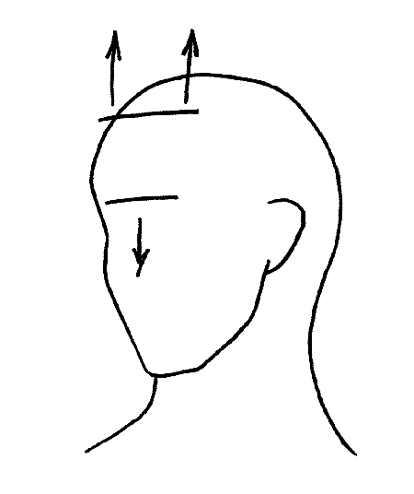
The preferred method is to use a flat sable brush (between 3/8” to 1” in width, depending on the area to be aged). The application changes only in the tool by which you put the Sēlr to the skin. Use brush strokes that will complement the direction of wrinkles. For best results, apply 1 to 4 layers, depending on your variables (as many as nine layers were used in some areas for “Clockstoppers”). Be sure to powder your last stipple layer before releasing. Use the hand fan at a low setting to blow fumes away from air passages at any time.

While aging the face in sections, be careful not to come down too close to the mouth in the nasolabial area. This allows too much material to build up around the mobile area, causing a constant need for repair. Remember to keep your fingertips powdered at all times.
Furrow Lines – area between
Brows is pulled upward and
Outward.
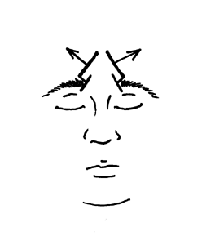
Forehead – subject scowls to
Lower brow line and hair line
Is pulled away from face.

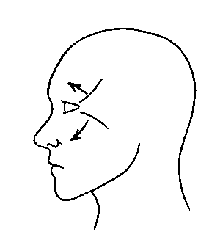
Crows Feet – pull away from
Outer corners of both eyes.
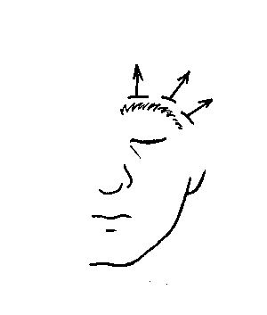
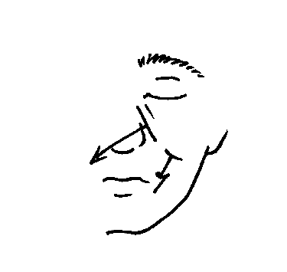
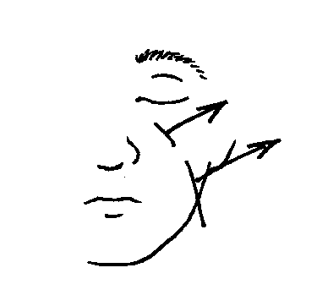
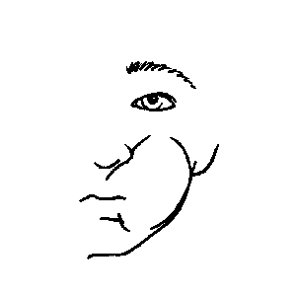
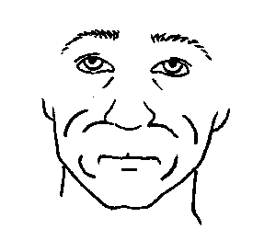
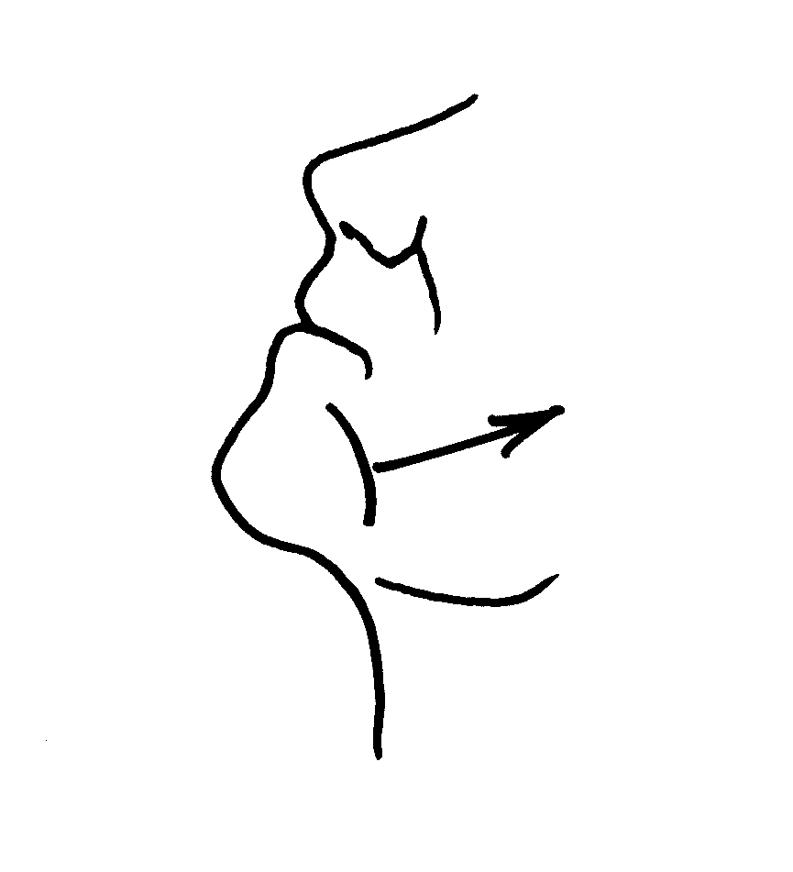
Eyelid – pull up at eyebrow –
Both eyes.
Under Eye Area – pull down
And toward center of face –
Both eyes.

Nasolabial – (both)
Option 1 – lift area away from
Center of face.
Option 2 – puff area to be aged

Upper Lip – puff entire area to
Be aged (use hand fan)

Chin – with neck arched, pull
Both sides of chin away from
The center of subject’s face.

Option 1 Option 2
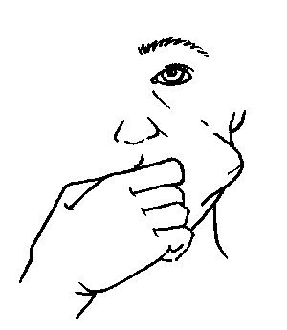
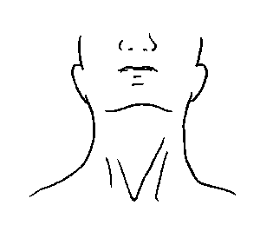
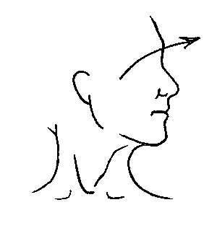
Cheek – using the subject’s index
Finger, reach deep into cheek and
Push out. This is a perfect opportunity
To tie the nasolabials, under eye area and
Crows feet together. Both sides.

Neck –begin with head back.
Throat first. Then with head
Turned. Both sides.

*Based on experiments for “Clockstoppers”, the use of a sponge trapped air onto the surface of the makeup, giving it an undesirable effect.

REPAIRS & QUICK FIXES

Depending on the thickness and placement of the ager, areas of the face may crack or flake, creating a look of severe damage. Do not panic. This usually happens around the mouth, just before or after lunch and near wrap. Repairs can be done quickly and easily by using any of the following three methods:

- Paint 99% alcohol in the direction of the wrinkles.
- Apply telesis 4 thinner and/or acetone (faster) with a brush. Then apply Green Marble SēLr (use a brush, sponge or spray).
- Apply the original ager material.

Temporary Patching: This technique is particularly useful when you do not have the time to do a thorough repair. Temporary patching mediums include:

• Oil free sodium based moisturizers (Kiehls, Kiss My Face, etc.)
• KY jelly
• 99% pure clear aloe. This technique was extremely successful while filming in Georgia’s summer heat. The high Humidity of the location was definitely a factor in the choice to use a plant-based product.

****************PPI LOGO AND INFO **********************************

The information enclosed is based on makeup tests conducted on actual productions by Richard Snell, Kenny Myers, Douglas Noe and Deborah Patino.

